**Types of Order**

1. Connect - N
2. Disconnect – Always need CKT in BPP to load a disconnect Order
3. QRD (Quick Release Disconnect) - Always need CKT to load a QRD. These types of order does not Get TFAS.

**How to differentiate Connect, Disconnect and QRD**

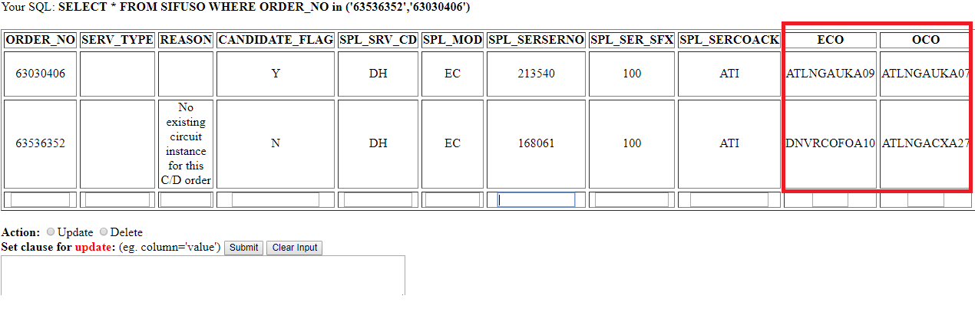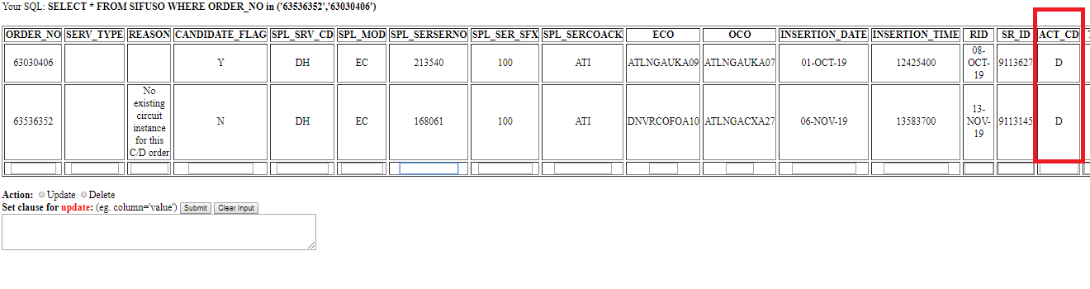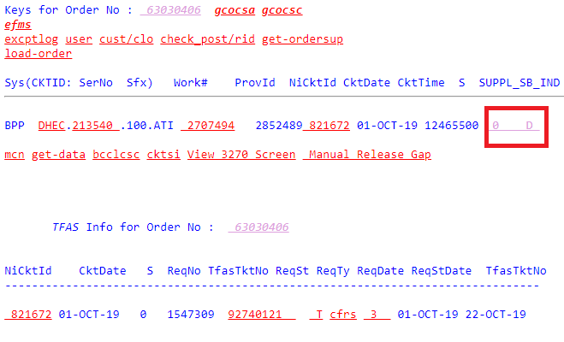

**How a good CKT Looks**

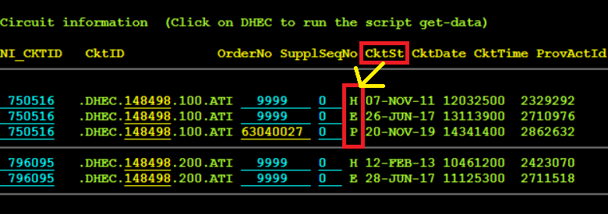

**H-E-P**

**S-H-E-P**

**S-H-H-E-P**

**S-S-H-H-E-P**

**E-H-P-E**

And More, Make sure Order always loads on “ P” CKT St and one above the Order is always “E”.

We can also change the CKT ST – using Production status. change-toie-new

**Most used Production Scripts- GUI**

1. tgo2sb – To Push to New Scheduling Blocks
2. sb2_dbcls.pl- To Delete Order
3. del-ckt- To delete CKT
4. change-toie-new- Change the status of CKT (in-effect Order)
5. get-clo- to get CLO
6. set-clo.pl – to set CLO
7. sub_svc.pl- to fix DH Circuit in Service

**Different Scheduling Blocks**

ACMS_SB1 0700;

ACMS_SB2 0705;

DRP_SB1 0300;

DRP_SB2 0310;

DRP_SB3 0320;

FEF_SB1 0400

**Most commonly used SQL Tables we use**

1. SIFUSO- This
2. ORDSTACK
3. COMPREQ
4. CKLACCLOC
5. CKTLOC
6. CIRCUIT
7. CKTSUBFAS- Assignt_act
8. EXCPTLOG